Git is Software

Github,Git lab, Git Bucket is hosting service

Snapshot – taking photo in freze state

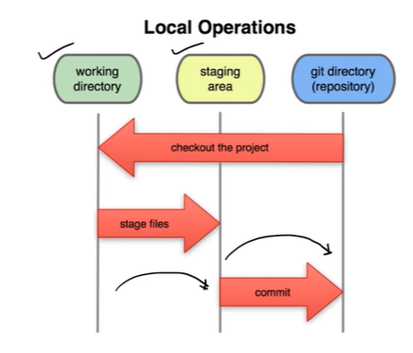

.git file is working directory it contains all the record changes

Staging area means it is almost ready to commit state

|  |  |
| --- | --- |
|  |  |
| git status | To check the status |
| Git init | Initialized and empty git repository |
| Git add --a | Add all the file in the staging area |
| Git add . | Add all the file in the staging area |
| Git commit -m “my first change” | Commit the code to local repo from staging area |
| Git add first.txt | Add particular file |
| Git log | Check the commit log |
| Git clone url | Clone the repo |
| Pwd | Present directory |
| Touch test.log | It will generate test.log file in the repository |
| Touch .gitignore | A file will be generated with .gitignore and In this file it will contains the file name which need to be ignored by git . To add all log file we can add inside the file *.log . It means where ever it will get .log file it will ignore it.  To ignore any directory /dirName need to add inside .gitignore |
| Git diff | It will check the difference(compare) between staging area and working directory |
| Git diff --stagged | It will check the difference(compare) between staging area and working directory |
| Git commit -a -m “Direct Commit” | It will commit the tracked file directly . But we we create new file then we have to add first so that it will move to stagging area. |
| Git clone url myPanda | It will create a folder with name myPanda and will store the data into it |
| Git log -p | It will show the commit log as well as the changes made in the code |
| Git commit --amend |  |
| Git restore –staged first.text | To unStaged the file |
| Git restore first.text | To restore/discard the changes to the previous commit |
| Git checkout –first.text | To restore the file changes to last commit if its not in staged area |
| Git checkout -f | To restore all the file// all the changes to last commit if its not in staged area |
| git push origin | It will push the code to origin |
| Git config --global alias.st status | It means it will change command status to st.  Next time if we enter git st it will be equal to git status |
| git checkout -b dev1 | Creates new branch and change from master/ any other branch to dev1 |
|  |  |

